L3HARRIS 787 Briefing Station
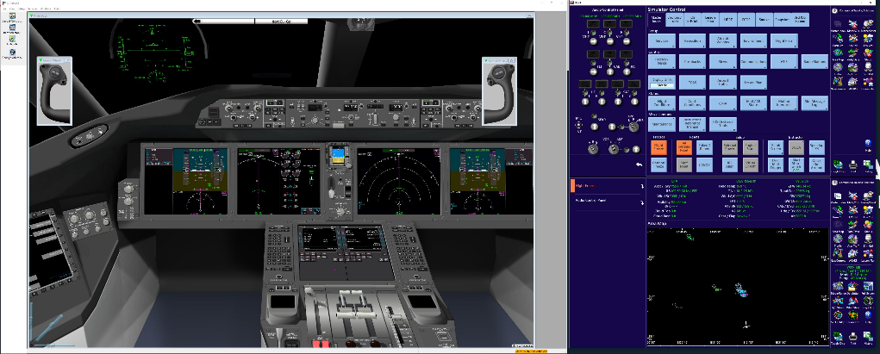
Quick Start Guide

** Start This Guide at the section relevant to condition the Briefing Station is found in **
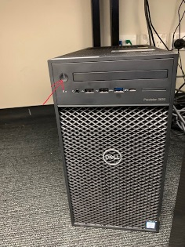
- Turn on briefing station computer (Figure 1)

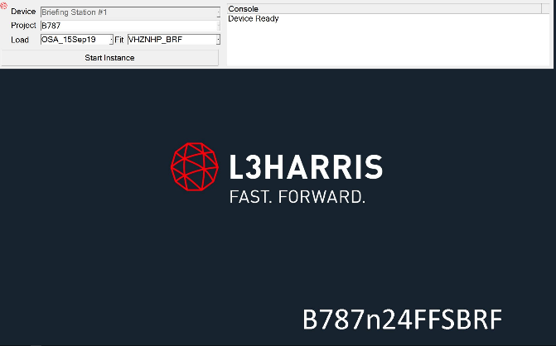
- “Splash” the launch program will auto start (Figure 2). If Splash is not running, click the icon on task bar to open Splash (Figure 3)
Splash program and Start Instance

Launch Splash Icon

- Select correct Load (latest date) and Fit (VHZNP_BRF)

- Click on the “Start Instance button” (Figure 2)

- Briefing program will load. Progress can be seen under “Console” Note: This may take a few minutes.

- Flight Deck and the IOS panels will display

- IOS and Flight Deck can be navigated using the Mouse and the Screens are also “touch screens”

- Access the user guide by either pressing F1 on keyboard or selecting the Help menu then Contents the user guide will open in an IE window.
Click on Allow Blocked Content
As a minimum read the Hints and Tips section
- The Aircraft will be in a “de powered” state

- Power up the Aircraft as per below
  - Set park Brake
  - Sim Freeze off
  - Battery Switch On
  - Wait 15 seconds after Capt Inboard and Lower EICAS screens display before proceeding
  - Select External Power on IOS and Overhead Panel or Start APU

- Operate as per Simulator with the addition that if positioned on threshold aircraft will “auto takeoff” when a TOGA button is pressed. Engage an A/P airborne. Above 200’ before 2000’.

** When finished using the Briefing Station please leave the Station as you would leave the FF Simulator**

